Introduction

Self-balancing robots have been a topic of interest of many researchers, students and hobbyists worldwide. In essence, it is an inverted pendulum on wheels, a derivative of the inverted pendulum on a cart. Unlike traditional robots, which are in a constant state of equilibrium, the self-balancing robot is a naturally unstable system; its design is more complex, as it needs to be actively controlled to maintain its upright position. The primary practical application of a self-balancing robot is human transportation, which was popularized by the release of the Segway.

This project aims to design, construct and program a self-balancing robot. To achieve the aims of the project, following objectives have been set:

• Design and assemble the chassis of the robot

• Develop the software to read from the sensors and to control the actuators

• Implement a PID controller to enable the robot to stay upright

This report discusses the theoretical considerations made at the start of the project, the steps that were taken to implement the self-balancing code, the analysis of the final results, the interpretation of the final results and finally the recommendations for future continuation of the project

Background research

The inverted pendulum is a classical problem in control systems, and to explore the unstable dynamics, different platforms have been developed. These platforms are similar in many ways, leading to many of the behaviors being comparable. The most common types are the self-balancing robot, Inverted Pendulum on a cart and an inverted pendulum on a linear track, shown in the figure below:

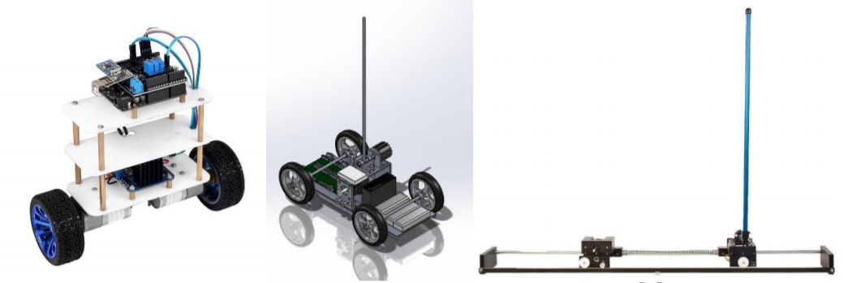

The Segway is a dynamic system that is commonly referred to as an inverted pendulum.

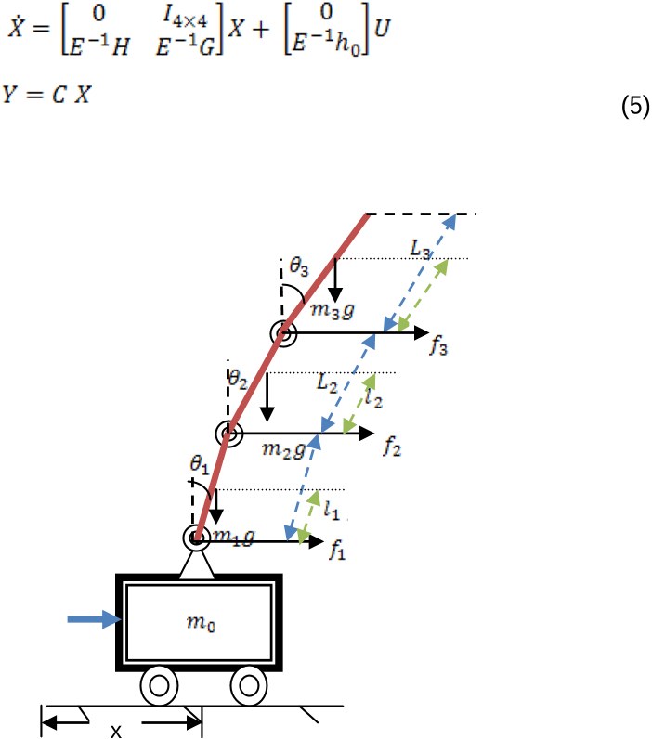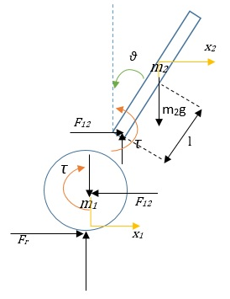

To form a two-wheeled inverted pendulum (TWIP), the pendulum is anchored to a base platform that has a wheel mounted on each side, as shown in Figure 1.3. In this case, a motor drives each wheel independently. The torque from the motors makes the base move to balance pitch angle of the pendulum. It can move along curved paths by driving the motors at different speeds. The two-wheeled inverted pendulum been proposed as a portable transporter due to its high maneuverability

The Segway personal transporter, shown in Figure 1.4, is a device that transports one person at relatively low speeds. The low-speed (limited to approximately 12 mph) operation combined with its electric propulsion system makes the Segway a candidate for providing short-distance transportation on city streets, sidewalks, and inside buildings. When a Segway is in use, the device is driven by two wheels that are placed side-by-side, rather than the standard in-line configuration of a bicycle or a motorcycle. When the operator leans forward, the wheels turn in unison in the same direction to provide forward motion. In order to stop, the wheels must accelerate forward to get out in front of the system's center of mass and then apply a deceleration torque to slow the system down without causing the operator to fall forward o the device. These operating principles are reversed to allow the system to move backward. In order to turn, the wheels rotate at unequal speeds causing the system to travel in an arc. If the system is not translating forward or backward, then the wheels can rotate in opposite directions to turn the machine in place. Given the side-by-side wheel configuration, and the elevated center of mass, the mechanical design of the transporter is unstable. It will fall over if the computerized control system is not continuously turning the wheels. This constant adjusting of the device is similar to a person balancing an inverted broom in their hand. In order to keep the broom upright, the person must continually move their hand in the direction that the broom is falling. The hand must pass to the other side of 9 Figure 1.4: Segway Personal Transporter. the broom's center of mass to generate a torque that will cause the broom to start rotating in the opposite direction. As a result, the broom is always falling, but the hand motion keeps changing the direction of the fall. Just like the inverted broom, the Segway and rider are always falling. However, it is not possible for the human operator to balance the device, as they can with a human-powered inverted pendulum such as a unicycle. The sensors in the device must constantly be measuring the state of the machine and feeding this information to the computer controller. The controller then uses this feedback signal to adjust the wheel speed so that the forward/backward (pitch) falling motion is maintained within an acceptable envelope so that device and rider do not fall over. Note that under many operating conditions, the system is mechanically stable in the side-to-side (roll) direction. Therefore, the computer does not attempt to control the roll motion. Assuming wheel-ground rolling stiction, the system is also stable in the yaw direction. However, the computer must change the yaw rate in order to turn the machine in 10 response to the operator input. It also limits the turning rate to a maximum value

Technical discussion / simulation study

The control algorithm that is used to maintain the balance on the autonomous self-balancing robot is the PID controller. The proportional, integral, and derivative (PID) controller is well known as a three term controller. The input to the controller is the error from the system. The Kp, Ki, and Kd are referred as the proportional, integral, and derivative constants (the three terms get multiplied by these constants) respectively.In the PID controller the error gets managed in three ways. The error will be used on the PID controller to execute the proportional term, integral term for reduction of steady state errors, and the derivative term to handle overshoots

Results

Conclusion

During the project a robot has been designed and built from scratch. Mechanically it looks and works as planned. A mathematical model of the robot and two control designs were calculated and simulated to verify the systems behavior.

References

Appendix